Microcomputer Design

Chandler Griscom

25Jan2016

Design Report #2

- Time – 31 Hours total
  - Week 2 (Wed-Sun) – 13 Hours
  - Week 3 (Mon-Wed) – 18 Hours

- Accomplishments
  - Ordered all components
  - Finished component symbols in PCBArtist
  - Schematic is 90% finished (awaiting more testpoints, LEDs)
  - Drew block diagram for Monitor program
  - Received Digikey and most eBay orders in mail

- Planned Work
  - Finish schematic by Friday
  - Discuss footprints and schematic with other students to find mistakes
  - Print out footprints and compare with actual components
  - Begin drawing PCB layout. Investigate pricing options.

- Project Completion
  - Hardware: 30%
  - Software: 2%

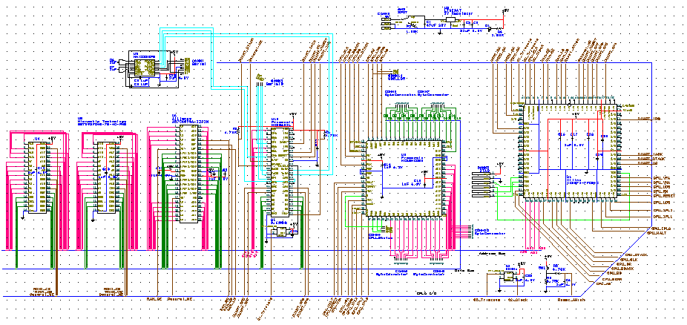
(Schematic Progress 25Jan2017)

